**Art Deco**

Sharon Jordan

Art Deco was the predominant decorative style in Europe and the United States between the World Wars, with its peak of consumer popularity reached during the late-1920s. The new style and accompanying attitude were synonymous with being ‘modern’ as the design and appearance of Art Deco objects incorporated a unique and new vocabulary of forms reflecting the complexities and innovations of the emergent twentieth-century, with this period also known as the Jazz Age and the Roaring Twenties. Art Deco is associated with the hedonistic abandon of a post-war society that was determined to enjoy life once again, while the consumer embrace of newly designed products that popularized Art Deco reflects the dramatic social changes and technological advancements happening throughout this period.

Art Deco style is characterized by its preference for simplified geometric forms and stylized natural forms, including flowers, animals, and female figures in its decorations, with these motifs applied to objects in every area of architecture, furniture, industrial design, the decorative arts, fashion, jewelry, graphics, bookbinding, glassware, and ceramics. As a style, it is known primarily for its opulence in materials and sense of glamour, luxury, and prosperity, with one of its most defining features being the streamlined curve in the shape of many of its objects. The Art Deco synthesis of decorative elements brought together geometric and exotic shapes, luxurious materials, bold color, and heightened aestheticism. Certain Art Deco motifs also reflected popular geographic interests at the time. Zigzags, stepped pyramidal forms, and sunbursts were inspired by the Near Eastern and Aztec cultures, and by the interest generated from the recent discoveries in Egypt in the 1920s, including King Tutankhamen’s tomb. Art Deco designers continued to mine the French styles from the past for traditional elements that contributed a sense of Classical restraint and grandeur with elegant proportions and stylized natural motifs of figures, floral garlands, and cornucopias. But, like Art Nouveau, which it replaced in popularity, Art Deco as a style was thoroughly engaged with what was current and what it meant to be modern.

The collaborations among artists, designers, and fashion designers led to some of the most innovative and interesting examples of Art Deco ensembles, such as the tribal theme décor made by Eileen Gray, Paul Iribe, and Pierre Legrain for the home of successful couturier Jacques Doucet, or the textile designs by the artist Raoul Dufy for the fashion designer Paul Poiret. More moderate versions of these lavish interiors were soon available from the design studios affiliated with the leading department stores in Paris, including Lafayette, Le Bon Marché, and Printemps, all of which employed leading designers, such as Paul Follot, René Prou, and Maurice Defrène, to create designs that would appeal to the mass public seeking the same elegant sophistication available to wealthy connoisseurs.

French Art Deco in particular is characterized by its exquisite craftsmanship and its luxurious wealth of materials, as seen in the ensembles of Jacques-Émile Ruhlmann or the designers Süe et Mare. Ruhlmann’s corner cabinet in lacquered rosewood, of which there are several variations, takes its overall shape from the eighteenth century but features delicate inlays of ivory in the stylized floral bouquet decorating its front. A subtle rectangular border formed from ivory circles outlines the cabinet’s front subtly offsetting its square shape, with these circles then carried over to the decorations that adorn the base of the legs.

In the United States, the characteristic Art Deco architectural design included the ascendant stepped forms that were ideally suited to the slender form of the urban skyscraper made possible with the development of the elevator. Similarly, the streamlined aesthetic of the Art Deco curve was found to be ideally suited for apartment buildings, trains, automobiles, and furniture, with the rounded corners and gentle curves reflective of effortless and graceful forward motion and technological advancement. Industrial designers soon adopted the streamlined curve for consumer products, including radios, clocks, cigarette lighters, and other household appliances now being made from Bakelite and other new types of plastics.

Several factors were influential in the development and popularization of Art Deco beginning in Paris in the first decade of the twentieth century. Founded in 1901, the Société des Artistes Décorateurs worked to promote the most talented designers in France to reinforce the country’s position at the forefront of increasingly competitive European markets. This impetus was largely in response to the exhibits at the Universal Exposition in Paris in 1900, where the Art Nouveau style was seen as having become too commercialized and diluted. The Société’s efforts to organize another international exposition were initially delayed because of World War One. When finally realized, the Art Deco style was seen at its best expression in the various pavilions and ensembles at the Exposition Internationale des Arts décoratifs et industriels modernes, held in Paris in 1925, which drew over 6 million visitors, and from which the name Art Deco was eventually applied to describe what was the predominant style in the objects and exhibits on view.

From the 1925 Exposition, one prime example of French Art Deco is the pavilion ‘Hôtel d’un Collectionneur’ designed by Pierre Patout. The exterior features stepped architectural forms incorporating unadorned geometric shapes with an elegant plain façade and a variation of the restrained Classical vocabulary of columns and a decorative frieze. The overall building is a harmonious balance of square, circular, horizontal and vertical elements with solid and glass masses. Ruhlmann designed its Grand-Salon interior and this ensemble remains one of the best examples of Art Deco’s sumptuousness and overall eclecticism. The wall coverings featured a repeating red pattern of birds and floral garlands over a yellow ground that is carried over into the carpeting and the upholstery of the furniture. The relatively simple lines and shapes of the furniture may appear deceptively simple until the materials, craftsmanship, and beauty of each individual piece is recognized. For example, a large cabinet by Ruhlmann, Jean Dunand, and Jean Lambert-Rucki from this room is simple in form yet its luxuriousness comes from the black lacquer exterior incised with silver decoration depicting two animals. They are made from stylized geometric shapes and zigzag lines with these lines then angled across the top to echo the rays of the sun. The undulating sides of the cabinet balance the flat expanse of the middle while the subtle linear decorations are repeated throughout to lighten its overall solidity. Lacquer was a favored technique for furniture during the Art Deco period with Jean Dunand one of its masters. It was introduced by Japanese craftsmen and requires intensive labor, time, and expertise to achieve the smooth and flawless surface seen here.

Coincident with the efforts of the Société des Artistes Décorateurs to revitalize the design trade, leading Parisian artists similarly recognized the need to exhibit together, founding the Salon d’Automne in 1903. The group was responsible for introducing Parisians to the work of leading artists, including Paul Gauguin, Paul Cezanne, Puvis de Chavannes, Odilon Redon, and Henri de Toulouse-Lautrec among others. In 1905, the Salon d’Automne introduced the work of the Fauves, principally Henri Matisse and Andre Derain, whose liberated and abstract use of color and simplified forms designated them as ‘wild beasts.’ Matisse’s curving arabesque lines, along with the flattening of form, bold colors, and linear reductions occurring in modern art, were quickly adapted by commercial designers in the creation of Art Deco objects for sale to the wider public.

The formal experiments of Cubism led to an increased interest in geometric form and abstraction in many realms of art and design. The Italian Futurists also explored dynamic movement, speed, and the machine aesthetic. The exploration of movement using pure areas of color and non-representational forms permeates the work of Robert and Sonia Delaunay. They coined the term ‘simultaneity’ to characterize how their abstract imagery made of interpenetrating geometric areas of pure color visualized the rapid motion and movement that structured urban life. Soon, Sonia Delaunay began applying these designs to clothing and objects, which were sold through leading department stores and at her Simultané boutiques, including one at the 1925 Exposition.

The Ballets Russes was one of the most important influences on the development of visual culture in the 1910s. Brought to Paris in 1909, the performances by Serge Diaghilev’s company and his talented collaborators, including the designer Léon Bakst, astonished audiences and inspired designers with their enveloping and intoxicating mixture of ornament, pattern, and color in spectacles evoking exotic and far-away realms or rhythmic Cubist modernism in the dancing, costumes, and scenic designs for their varied productions.

One example of how these ideas from the visual arts were translated into the realm of Art Deco is seen in furniture designer André Groult’s chiffonier or bureau made for a woman’s room of a pavilion at the 1925 Exposition. Its anthropomorphic shape echoes the curvaceous female form and it is made from typically exotic materials, including ivory keyholes and sharkskin, also known as shagreen, in a bold yellow color. The shagreen has been applied in the pattern of a large sun at the bottom emitting rays that alternate into squares and circles as they reach the top resulting in an exciting yet restrained object in which its sophisticated and luxurious appearance are its foremost concerns.

Throughout the beginning of the twentieth century, the appeal of the exotic was continually fueled by France’s vast colonial territories, inspiring an interest in primitive or tribal forms from Africa; an interest in new techniques and aestheticized surface qualities, including lacquer and ceramic glazing from Asia; and the use of rare and exotic woods, semi-precious stones, and other materials from the colonies, such as sharkskin, tortoiseshell, and ivory for inlays. African objects and sculptures had helped modern artists, including Henri Matisse and Pablo Picasso, to harness the geometric forms and bold linear elements seen in African objects to formulate their abstract vocabularies in the fine arts that soon revitalized imagery in the design realm during the Art Deco period.

Travel, adventure, and the ongoing contemporary interest in these faraway colonial destinations supplied motifs that were applied to graphics and advertising using streamlined Art Deco forms. After the restrictions in place during the war, many people were now captivated by the allure of travel and leisure made increasingly accessible with the automobile, railroads, and luxury ocean liners. Some of the most representative examples of Art Deco came from these trans-Atlantic cruise ships. A poster by A. M. Cassandre, a leading graphic artist, advertises the Normandie, one of the largest cruise ships from this era, in which the tall elegant ship glides majestically through the calm water, its bow featuring the streamlined curve so representative of Art Deco. Onboard these cruise liners, the luxury and craftsmanship of Art Deco realized its fullest expression in fantastical and lavish ensembles of furniture, lighting, and artworks that fulfilled the most opulent and luxurious tastes.

Much of Art Deco appears in hindsight as a glittering façade that hid ongoing economic hardships and political instabilities. In the United States, Prohibition led to the rise of organized crime and a sense of illicitness associated with jazz clubs and popular culture. As many people sought to escape their mundane daily concerns, the movies provided a great refuge. Costumes, sets, and lighting were all vehicles for popularizing the elegant and seductive atmosphere of Art Deco.

The popularity of Art Deco waned as interest grew in cost effective mass production and industrial materials, such as tubular steel, that lacked excess ornamentation and was suited to the ethos of ‘form following function’ that began to influence the direction of modern design from architects such as Le Corbusier and Walter Gropius. The burgeoning modernism of the Bauhaus aesthetic existed harmoniously with the streamlined Art Deco to an extent as the chaise-lounge chair by Le Corbusier, Pierre Jeanneret, and Charlotte Perriand in chrome-plated tubular steel covered with cowhide upholstery illustrates. The disregard for cost or practicality in the materials and the opulent designs of Art Deco ensembles eventually led to its demise, an end that was inescapable with the beginning of the Great Depression in 1929 and escalating political tensions throughout Europe in the 1930s.

The most triumphant crowning examples of Art Deco architecture are the skyscrapers in New York City, including the Chrysler Building, 1927-30, and the Empire State Building, 1929-31. Geometric and stepped pyramidal forms in each evoke the streamlined aesthetic that prevailed in the preceding period. These serve as a dynamic reminder of the Art Deco, the final design style of the twentieth-century that was conceived of as a complete and all-encompassing program uniting architecture, arts, clothing, graphics, and the applied arts.

Further Reading:

Arwas, Victor. *Art Deco*. New York: Abrams, 1986.

Battersby, Martin. *The Decorative Twenties*. London: Herbert, 1988.

Benton, Charlotte, Tim Benton, and Ghislaine Wood, eds. *Art Deco 1910–1939*. London: V&A Publications, 2003, reissued 2015.

Brunhammer, Yvonne, and Suzanne Tise. *The Decorative Arts in France, 1900–1942: La Société des Artistes Décorateurs*. New York: Rizzoli, 1990.

Goss, Jared. "French Art Deco". In *Heilbrunn Timeline of Art History*. New York: The Metropolitan Museum of Art, 2000–. http://www.metmuseum.org/toah/hd/frdc/hd_frdc.htm (June 2010)

Hillier, Bevis. *Art Deco of the 20s and 30s*. London: Studio Vista, 1968.

Lowe, David Garrard. *Art Deco New York*. New York: Watson-Guptill, 2004.

Troy, Nancy J. *Modernism and the Decorative Arts in France*. New Haven: Yale University Press, 1991.

Wolf, Norbert. *Art Deco*. Munich: Prestel Verlag, 2013.

ART DECO IMAGES:

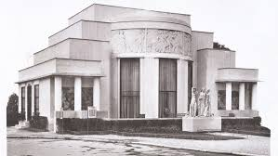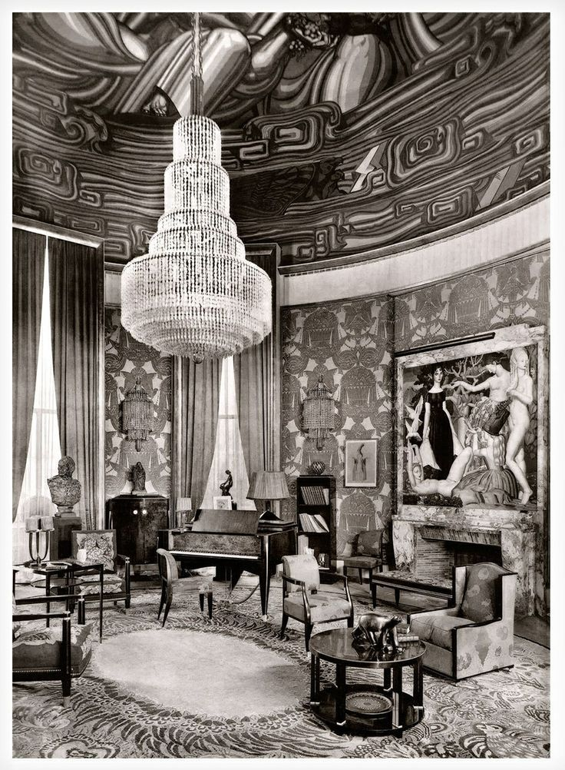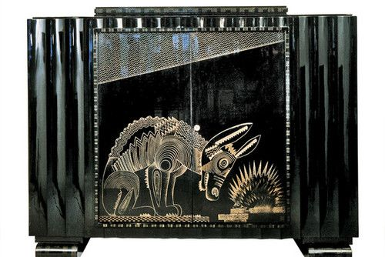

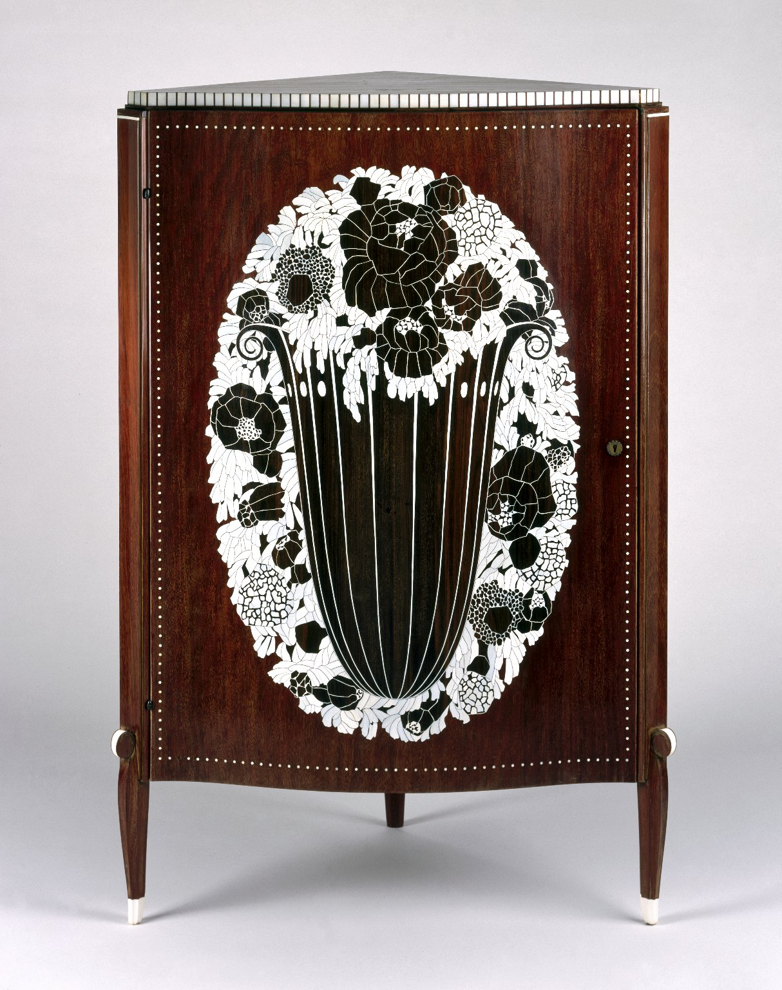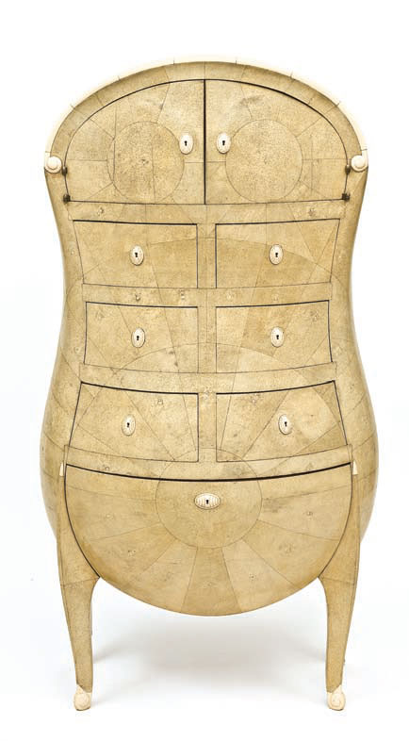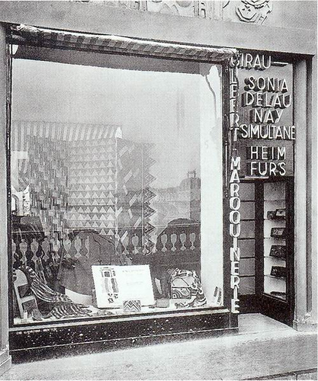

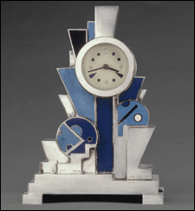 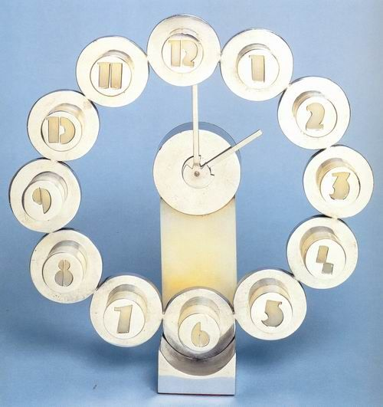 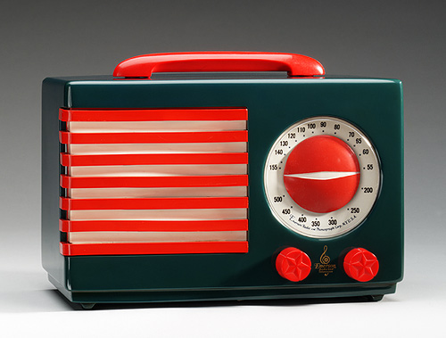

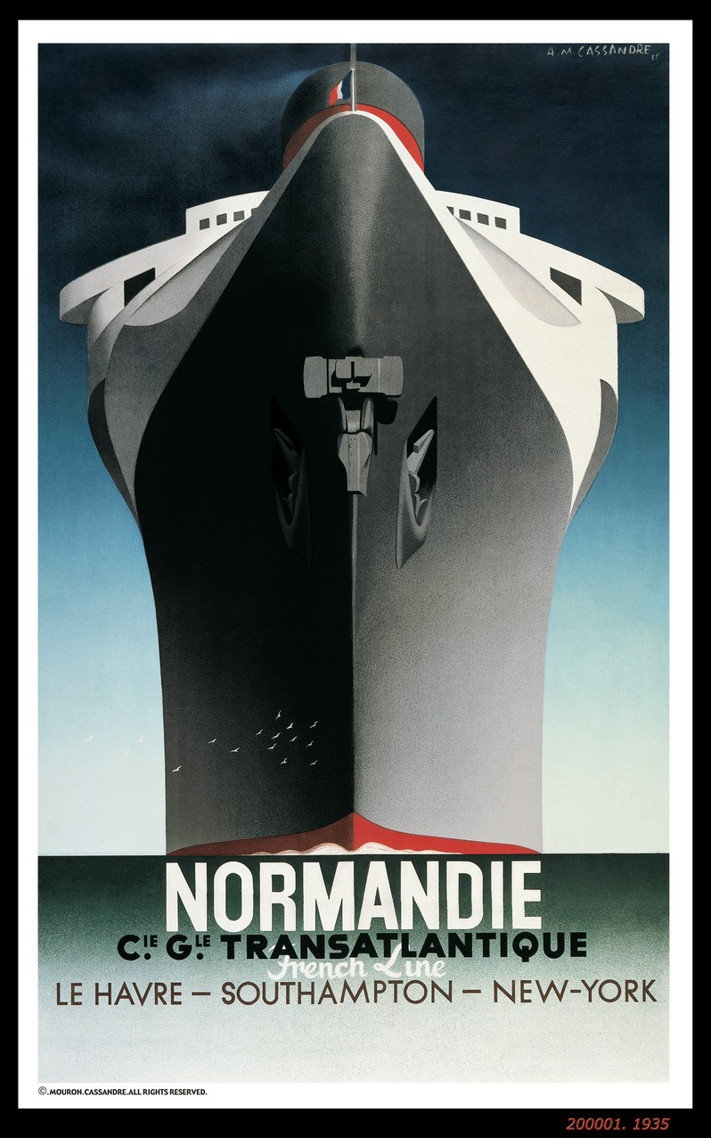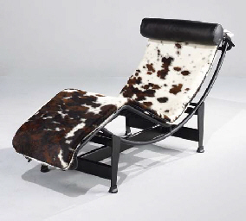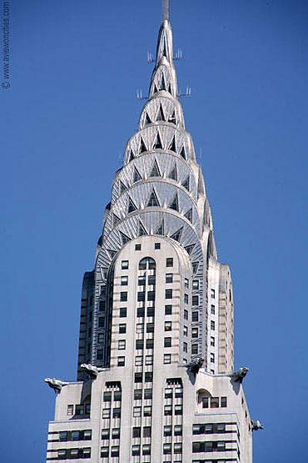

IMAGE CAPTIONS:

Pierre Patout, ‘Hôtel d’un Collectionneur’ pavilion at the Paris 1925 exposition.

Jacques-Émile Ruhlmann, ‘Grand Salon’ in the ‘Hôtel d’un Collectionneur’ pavilion at the Paris 1925 exposition.

Jacques-Émile Ruhlmann, Jean Dunand, and Jean Lambert-Rucki, cabinet. Black lacquer with incised silver decoration. French, 1925.

Jacques-Émile Ruhlmann, corner cabinet. Lacquered rosewood, ivory and rare woods, French, 1916.

André Groult, chiffonier. Mahogany, ivory, and sharkskin. French, 1925. Displayed in the ‘Chambre de Madame’ in the ‘Ambassade Française’ at the Paris 1925 exposition.

Sonia Delaunay, varied designs in the window of her Boutique Simultané, at the Paris 1925 exposition.

Jean Goulden, clock. Silvered bronze with enamel. French, 1928.

Jean Puiforcat, clock. Nickel-plated bronze and white marble. French, 1932.

Norman Bel Geddes, ‘*Patriot’* radio. Catalin plastic. American, 1939.

Adolphe Mouron Cassandre, *Normandie* poster. Color lithograph. French, first published 1935.

Le Corbusier, Pierre Jeanneret, and Charlotte Perriand, chaise lounge. Chrome-plated tubular steel, painted sheet steel, rubber, and cowhide upholstery. French, 1929.

William Van Alen, Chrysler Building, New York, 1927-30.